A000-Am,C-Taino-Cohoba Pestle-Anthropomorphic-Manatee Bone-1000 CE

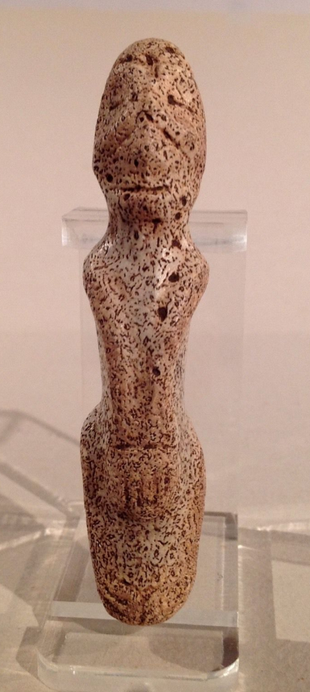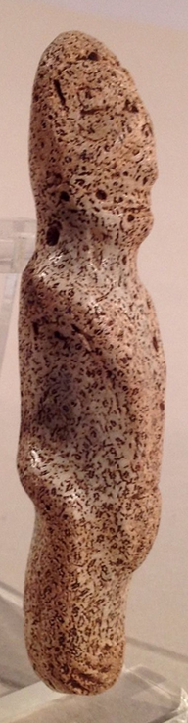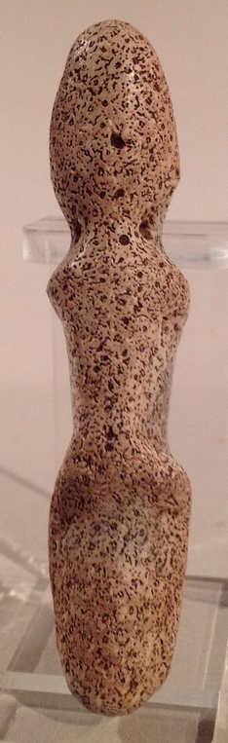

Figs. 1-3. **Am,C-Taino-Cohoba Pestle-Manatee Bone-1000 CE**

**Case No.: 18**

**Accession No.**

**Formal Label: Am,C-Taino-Cohoba Pestle-Manatee Bone-1000 CE**

**Display Description:**

Looking closely at this piece I see that the suspension holes were not drilled through. Still it has a high polish, facial details, with torso and definable limbs. Figure appears to be straddling a post. The base is round so it could have been a small personal cohoba grinder.

**LC Classification:**

**Date or Time Horizon: 1000 CE**

**Geographical Area:** Caribbean Islands, probably the Dominican Republic or Puerto Rico.

**Map:**

**GPS coordinates:**

**Cultural Affiliation:**

**Media:**

**Dimensions:** Length 8.8 cm. or 3.4 in.

**Weight:**

**Condition:**

**Provenance:**

**Discussion:**

**References:**